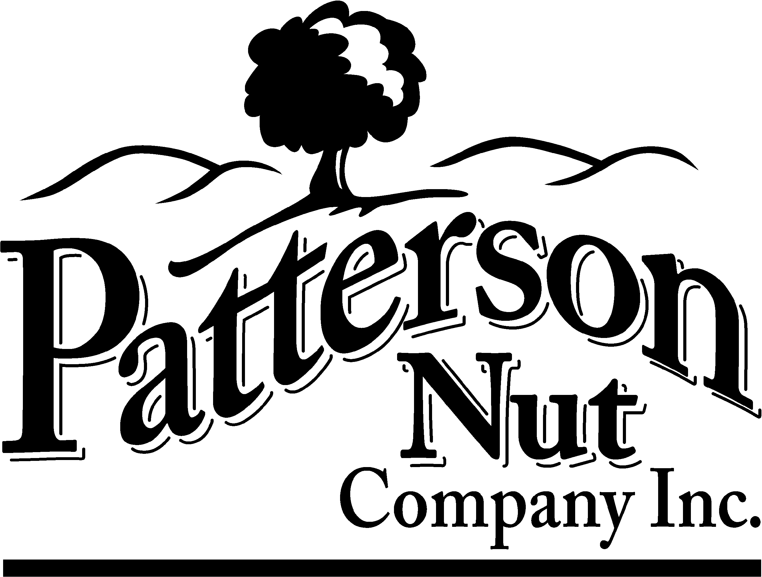

INGREDIENT STATEMENT

To Whom It May Concern:

SHELLED CASE WEIGHTS – 22, 25 or 30 POUND CASES

INGREDIENTS: SHELLED WALNUT KERNELS – NO ADDITIVES – A RAW
AGRICULTURAL COMMODITY.

Julie Hamilton
Patterson Nut Company, Inc.

Mailing/Billing: P. O. Box 122, Patterson, CA 95363-0122 E-mail: jhamilton@pattersonnut.com
Shipping/Receiving: 16801 Highway 33, Patterson, CA 95363 Telephone: 209.892.3458 Facsimile: 209.892.5036

Reviewed: April 2024
Revised: April 2024

