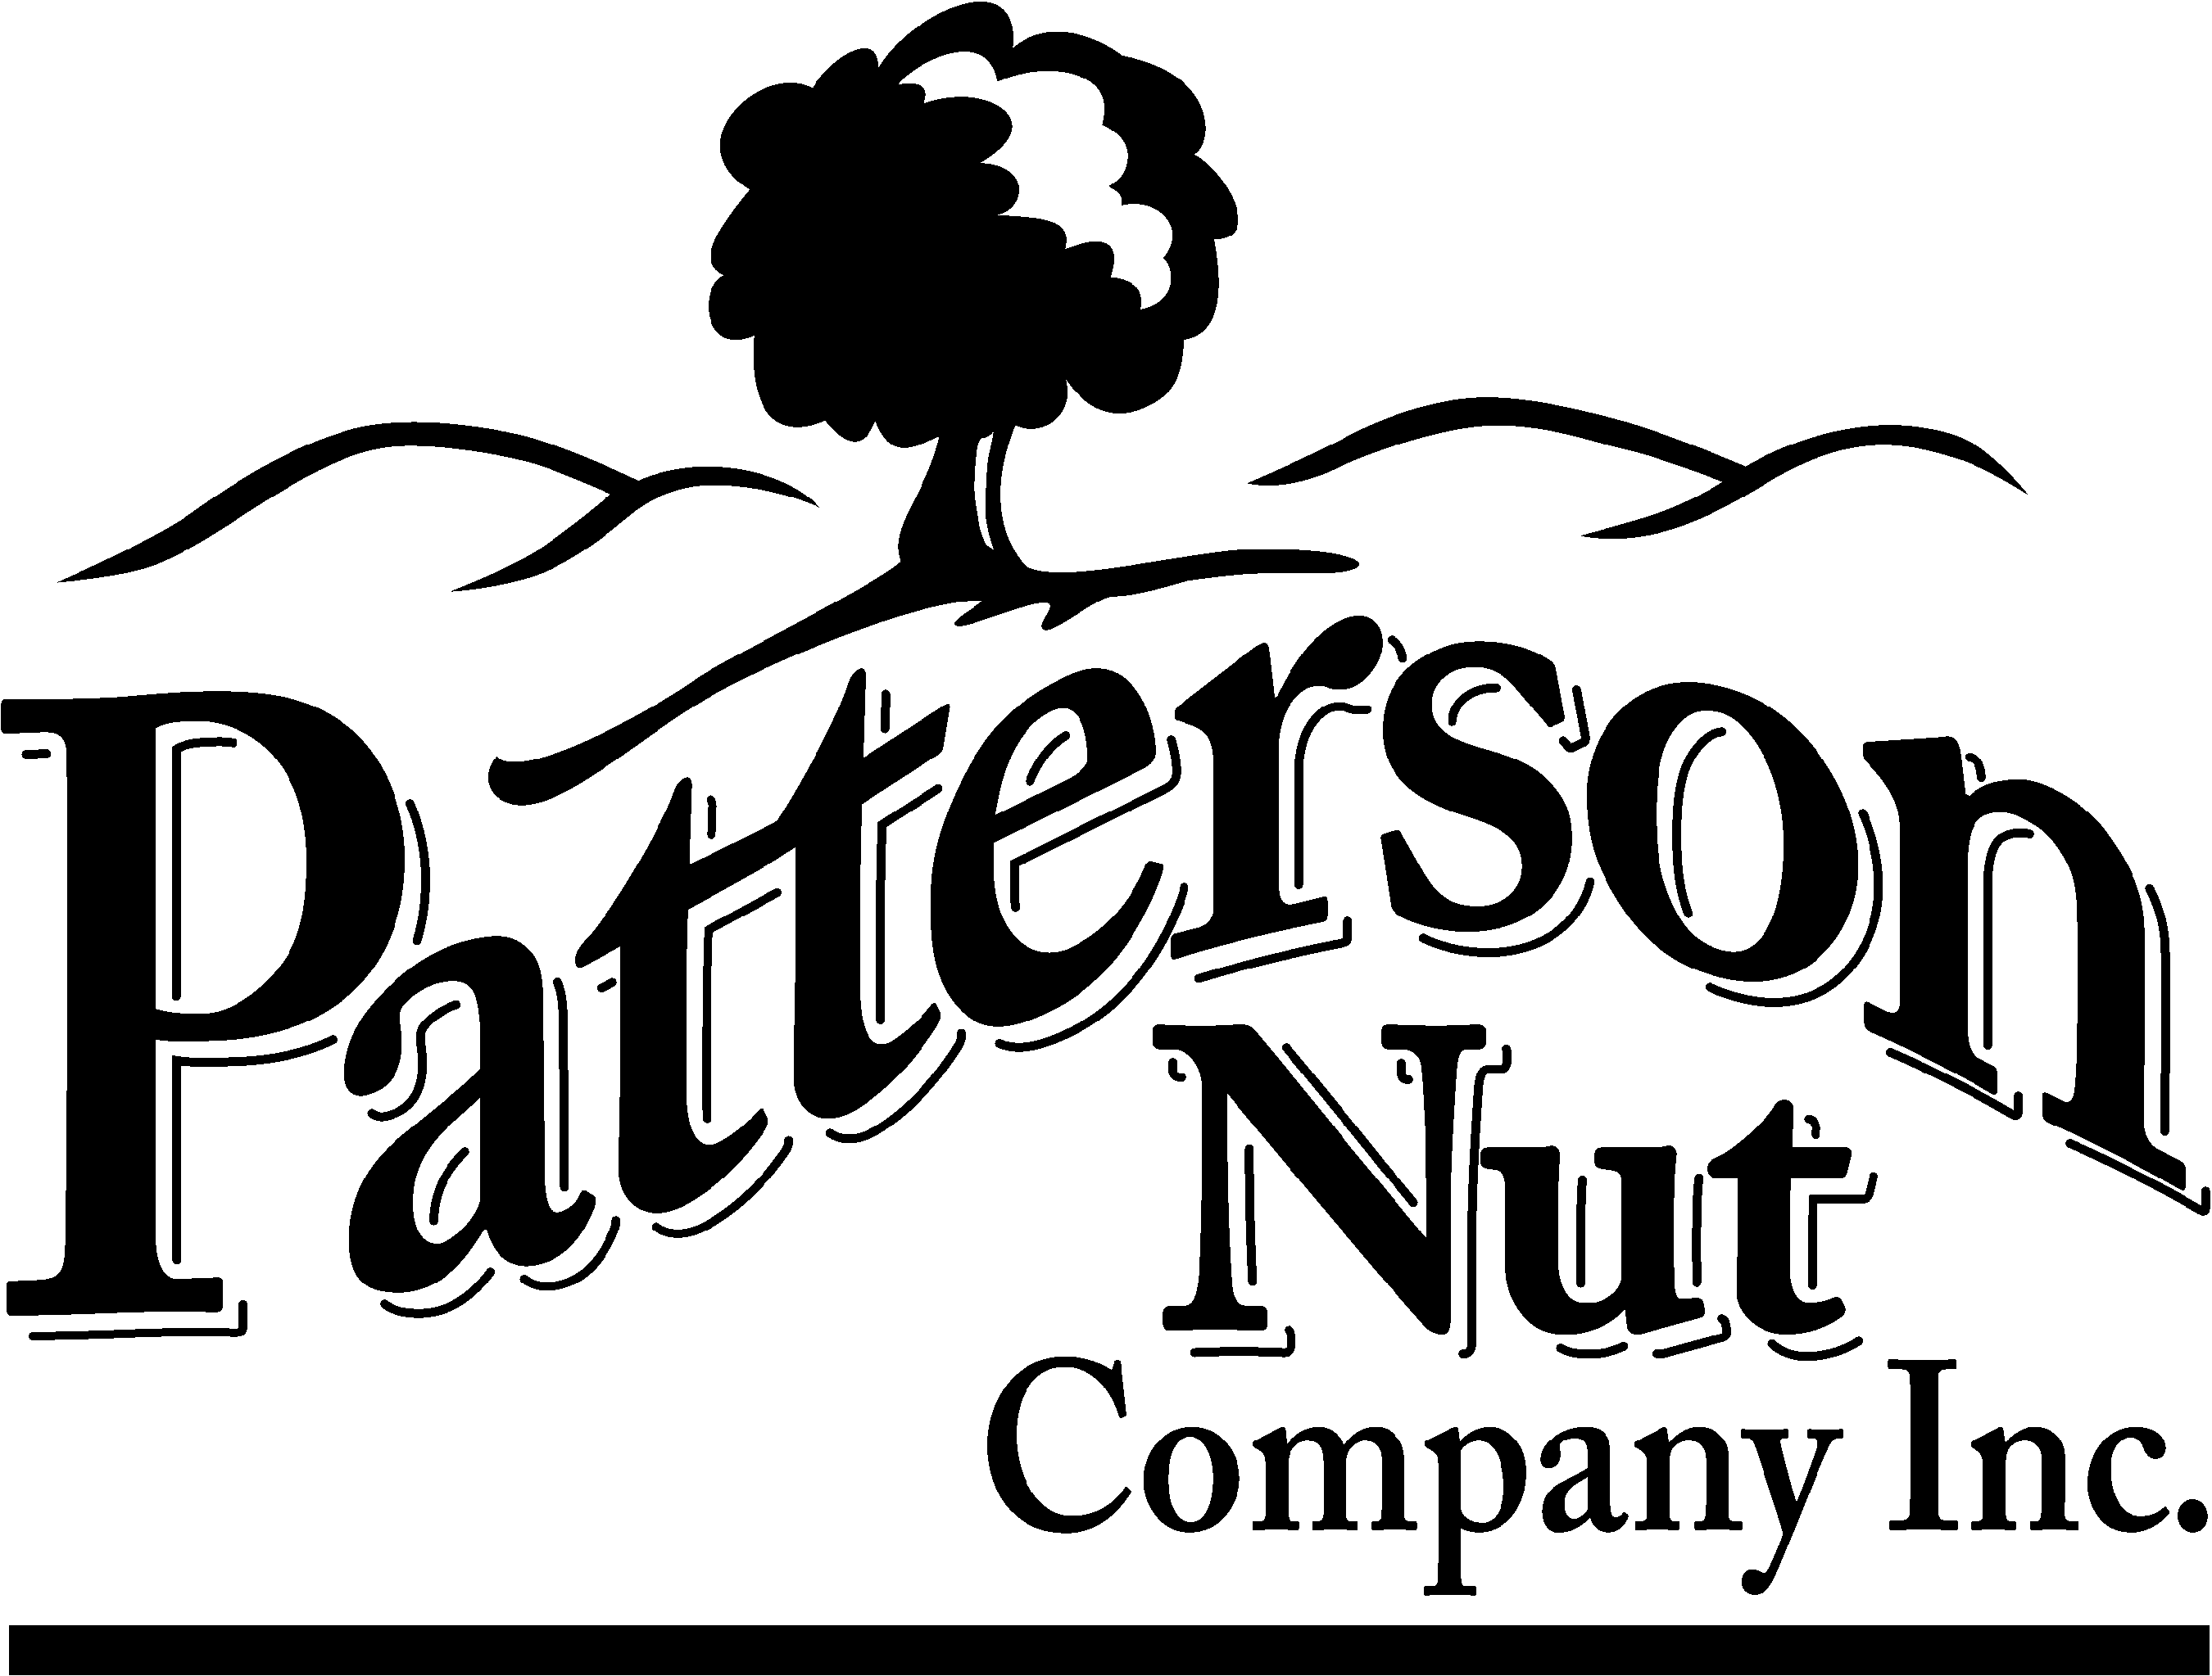

CONTINUING FOOD GUARANTEE

Date: July 29, 2026

To Whom It May Concern:

We certify that our walnuts are produced under the U.S. Food and Drug Administration’s Good Manufacturing Practices and Hazard Analysis and Critical Control Point (HACCP) programs. Also, our product is produced under State and Local Food Health Authority rules and regulations for the State of California and local County requirements. Our walnuts are inspected and certified by the DFA of California under the direction of the USDA. All outgoing products, both inshell and shelled, are required by Federal Marketing Order to meet USDA grade standards.

Julie Hamilton

Julie Hamilton
Patterson Nut Company, Inc.

Mailing/Billing: P.O. Box 122 Patterson, CA 95363 Telephone: 209.892.3458 Facsimile: 209.892.5036
Shipping/Receiving: 16801 Hwy 33 Patterson , CA 95363 Telephone: 209.892.3458 Facsimile: 209.892.5036
E-mail: kirk@pattersonnut.com / jhamilton@pattersonnut.com

Revised: April 2024
Reviewed: April 2024

